Caddywompus Controls

Collector/Feeder

Left Drive Motor

Right Drive Motor

Shroud Down

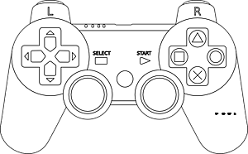

Toggle Shooter

Brass Rod

Shroud Up